**INFO 5505 – APPLIED MACHINE LEARNING FOR DATA SCIENTISTS**

**Assignment - 3**

**Data:**

The data in this assignment has trained and test data sets.

The objective of this assignment is to train a k-Means clustering on the given data.

**1.Data Loading**

The data is loaded into a data frame and verified using pandas library as shown below.

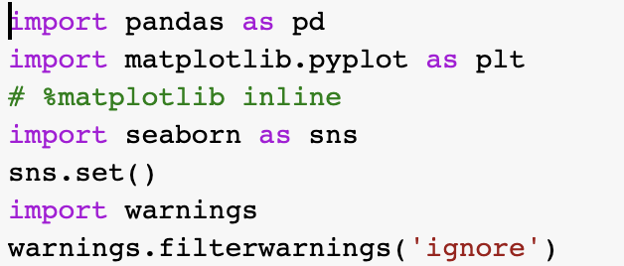

The trained and test data sets are loaded to data frames as below.



Trained data set:

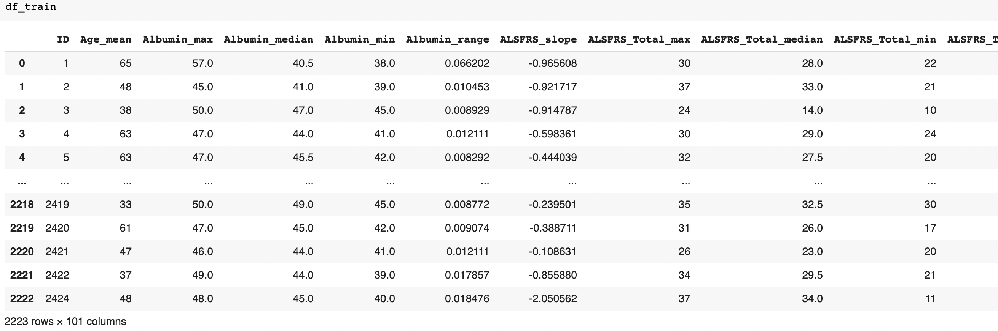

Test dataset:

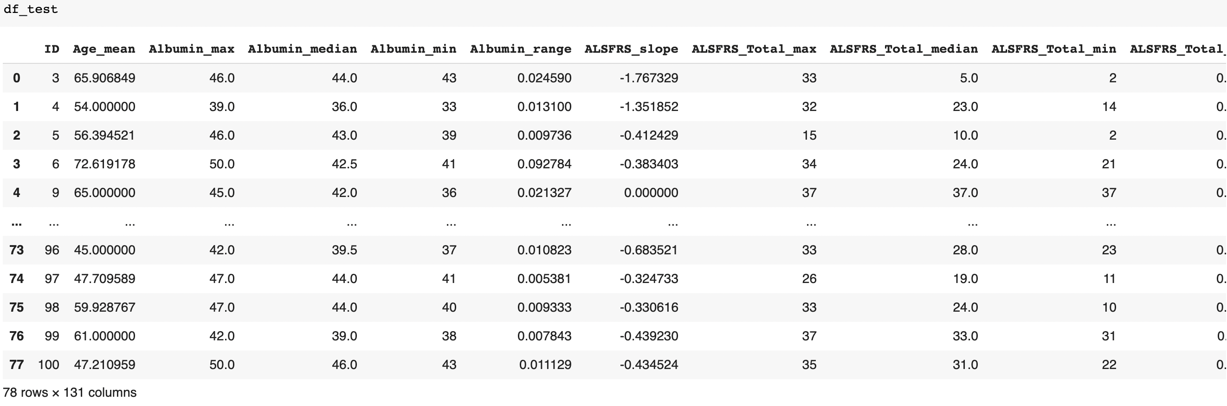

Description of train data set using “Describe” function:

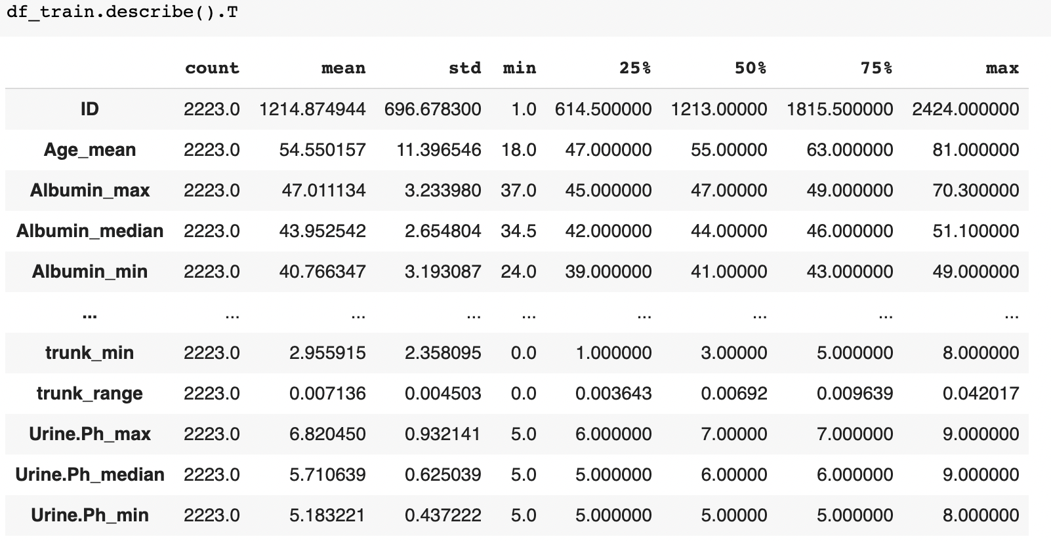

Description of test data set using “Describe” function:

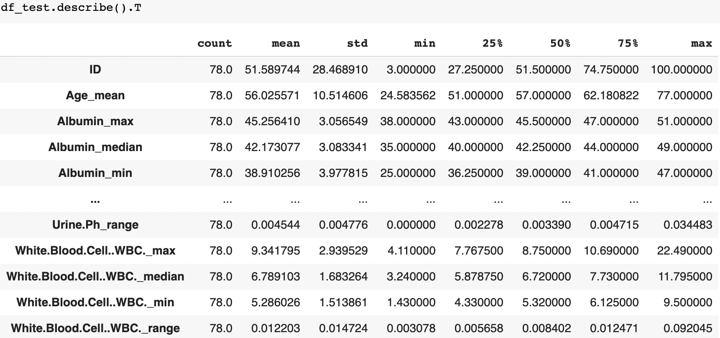

**Checking for missing values:**

Missing values are also checked by using msno matrix as shown below.

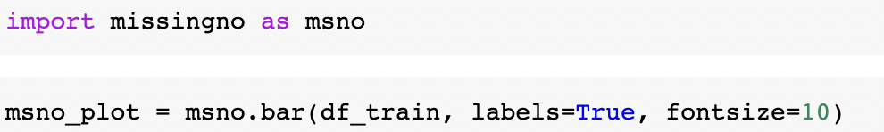

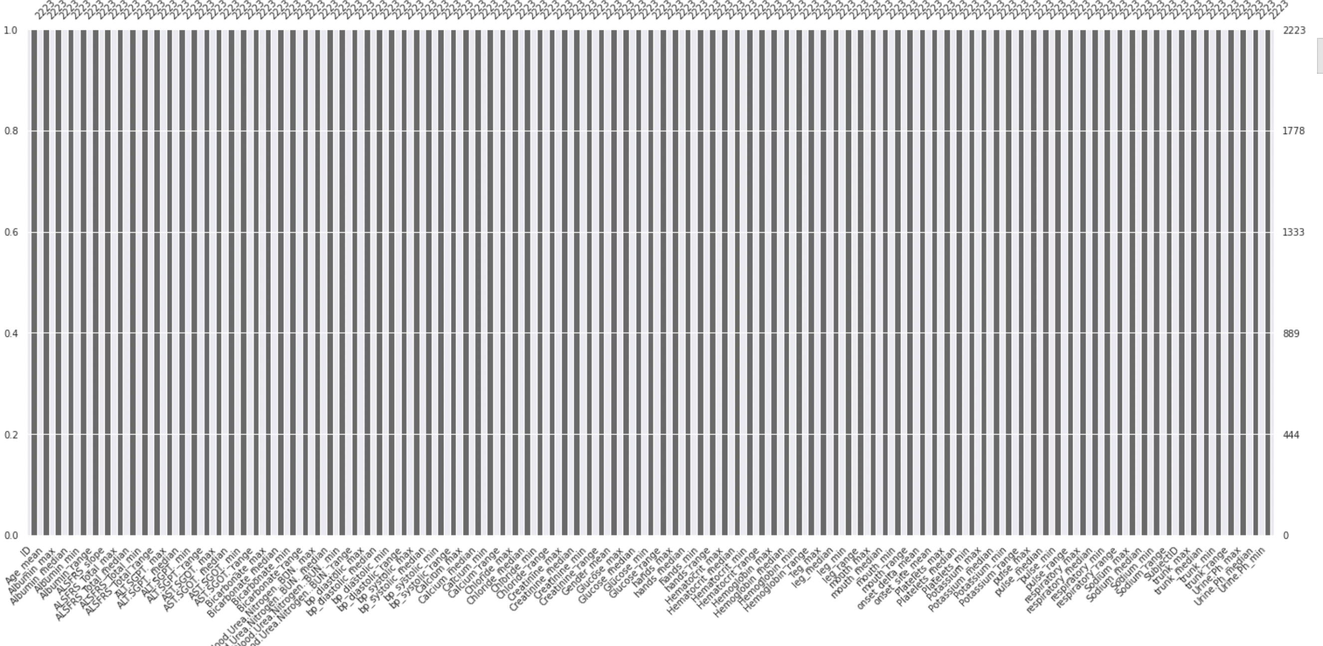

All the bars for each feature are full which says that there are no gaps (missing values) in the given data.

‘Id’ and ‘SubjectID’ columns are dropped to perform further analysis on the train data using below code:



To find the skewness of every column in the data, “hist” function is used to plot the histogram.

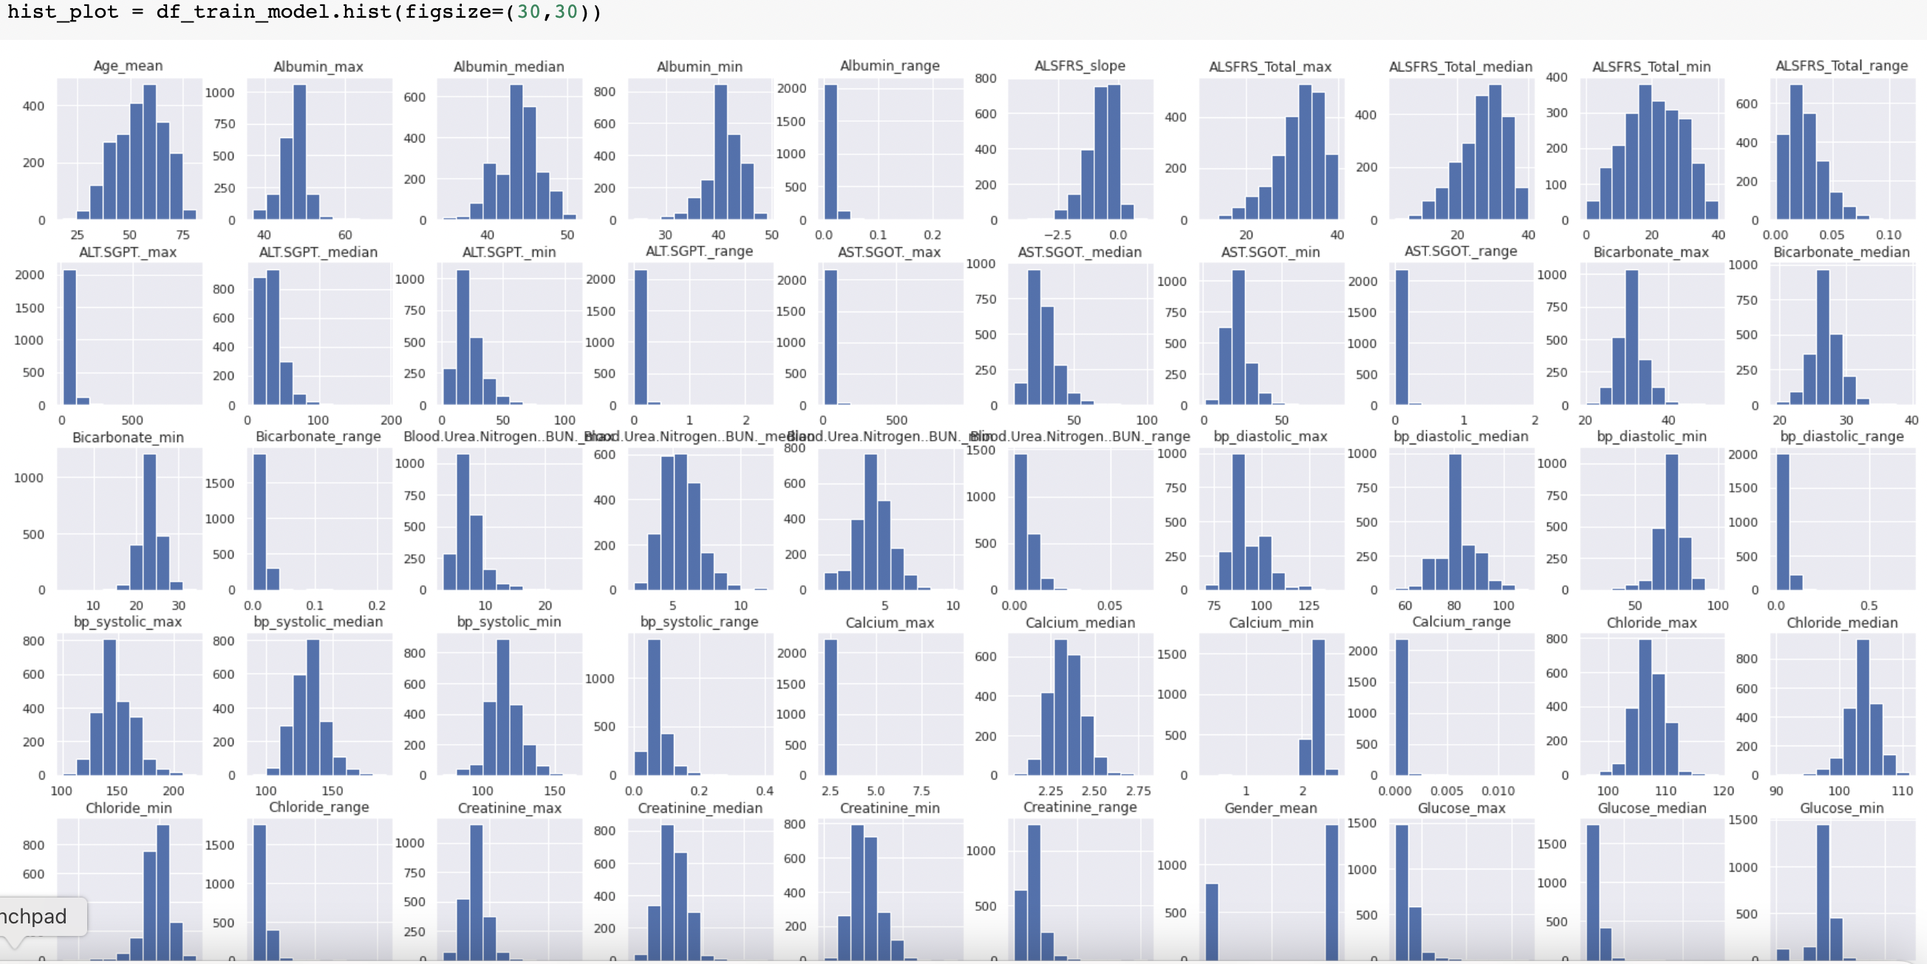

Density plot is used for visualizing the distribution of observations in a data set. Density plot for the train data model is drawn using code below:

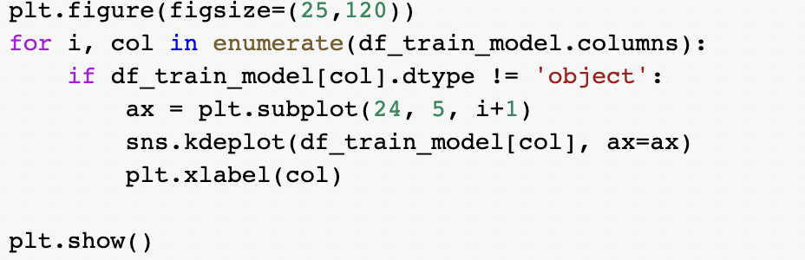

Density plot distribution is as below:

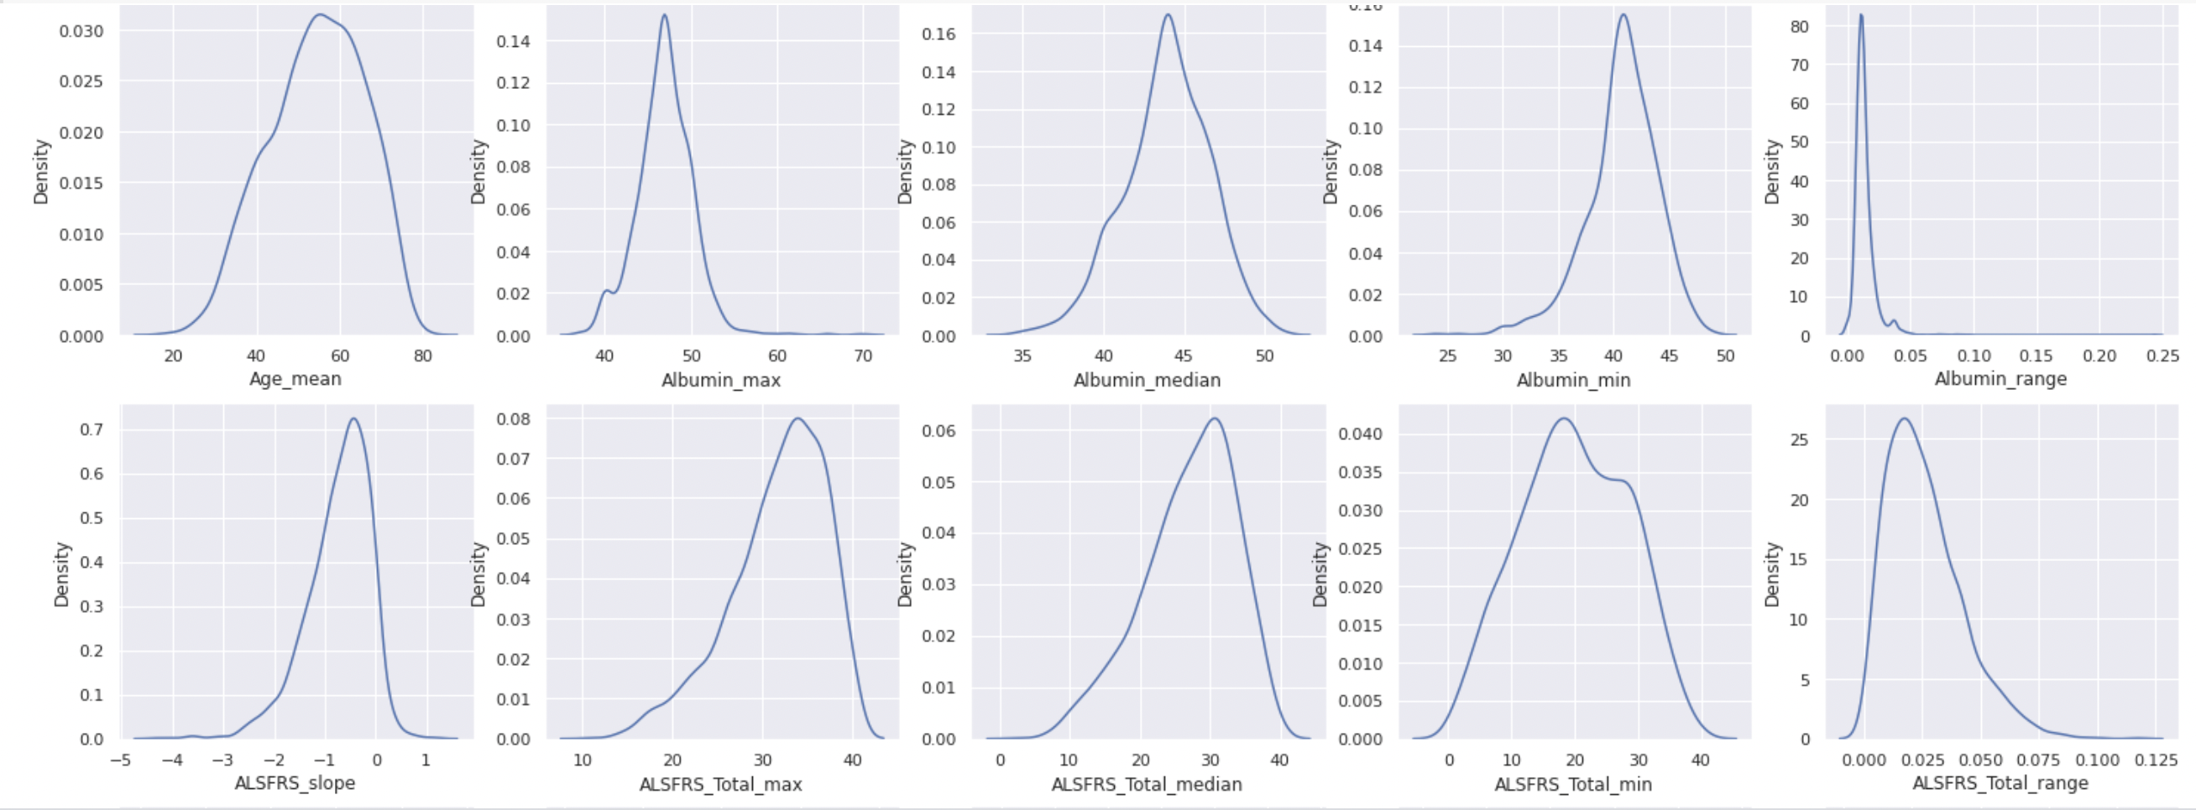

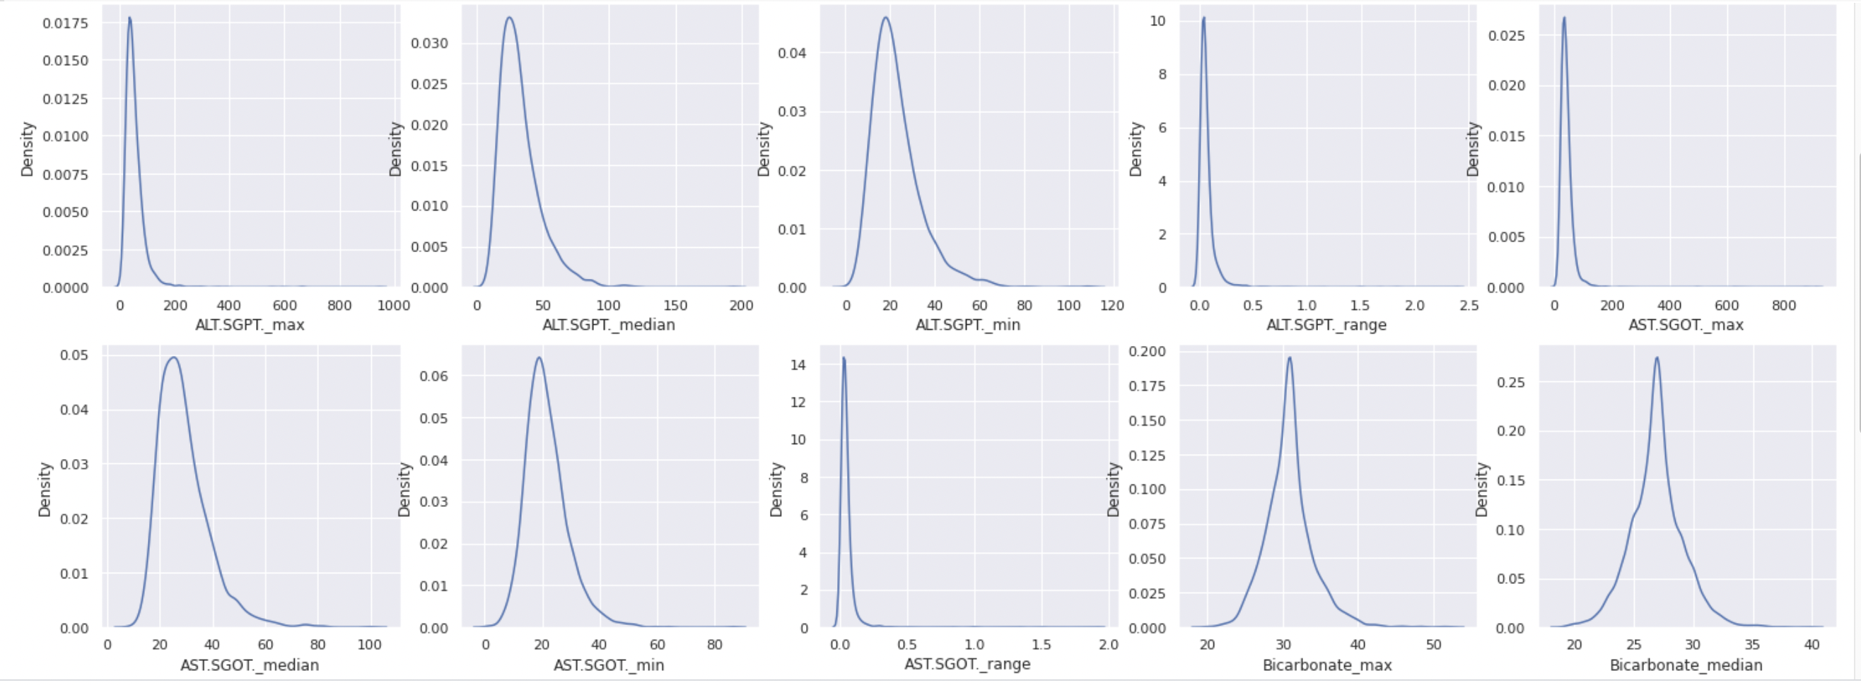

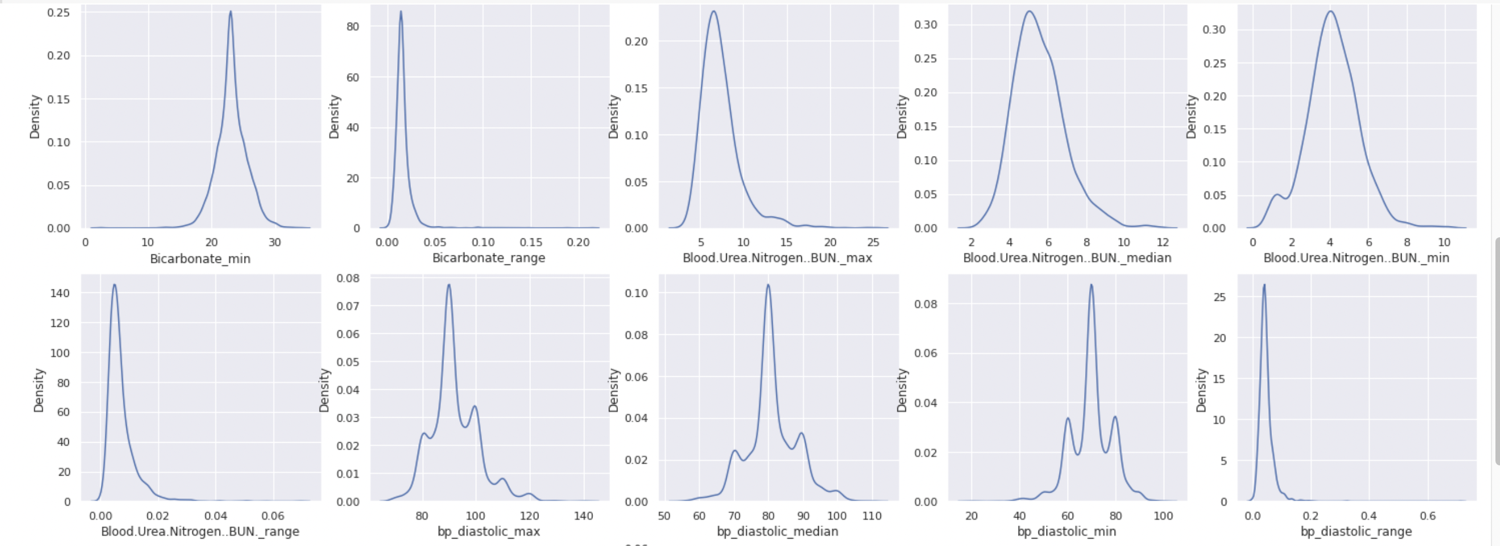

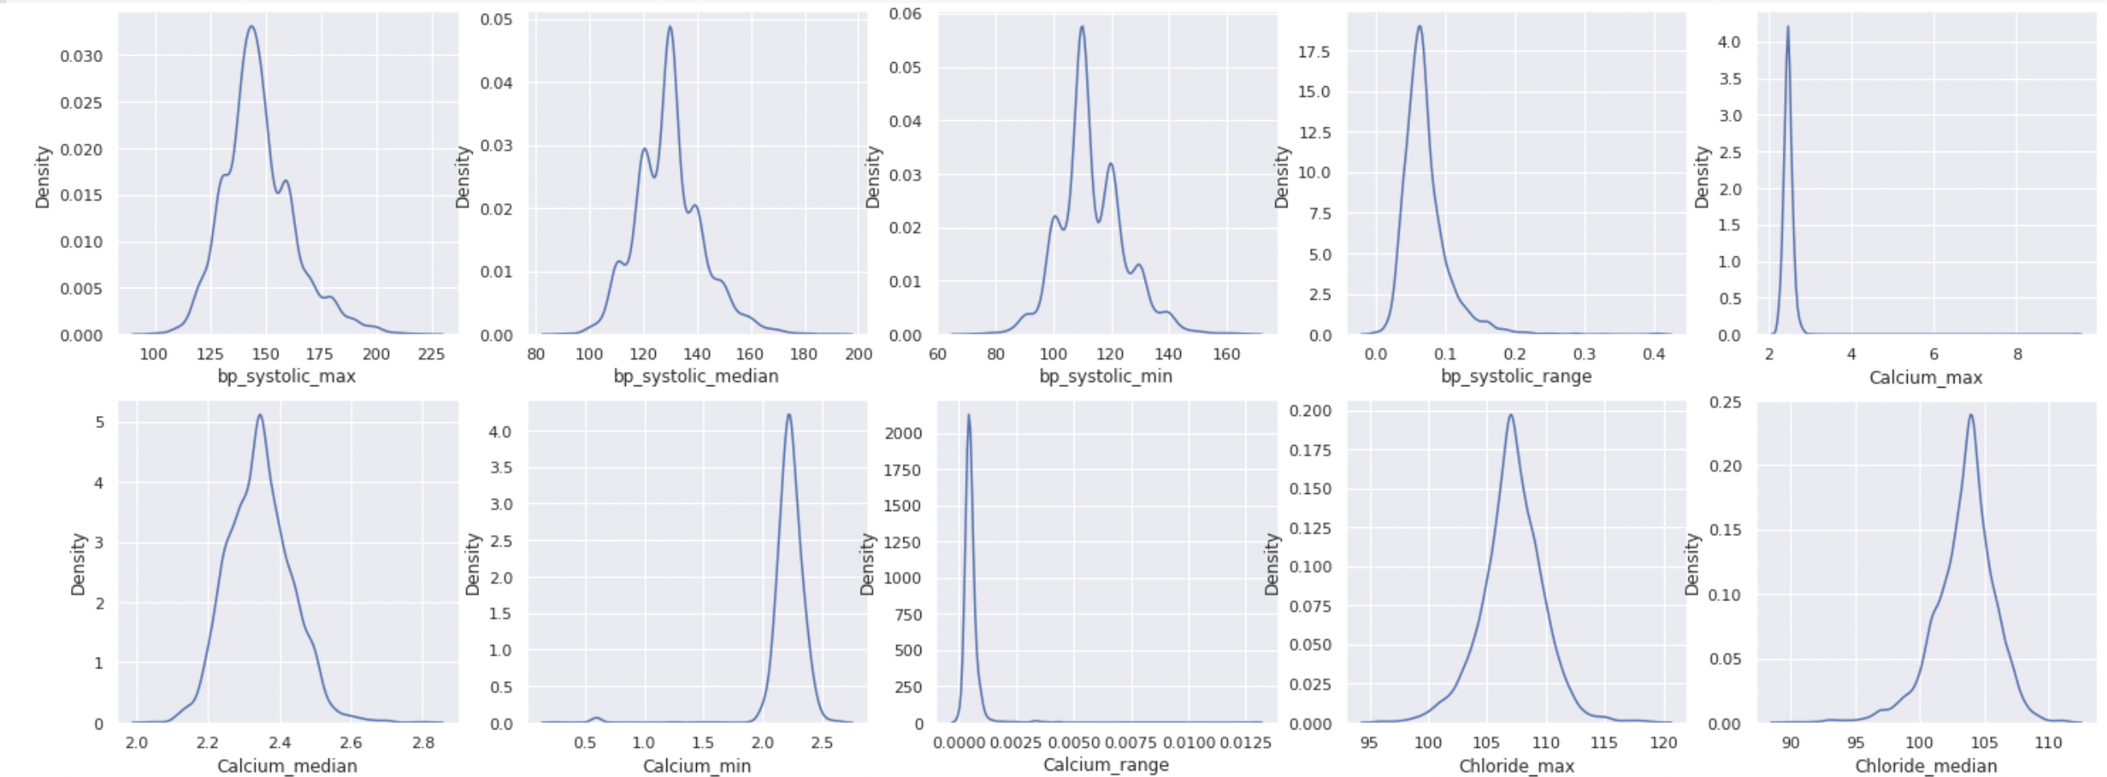

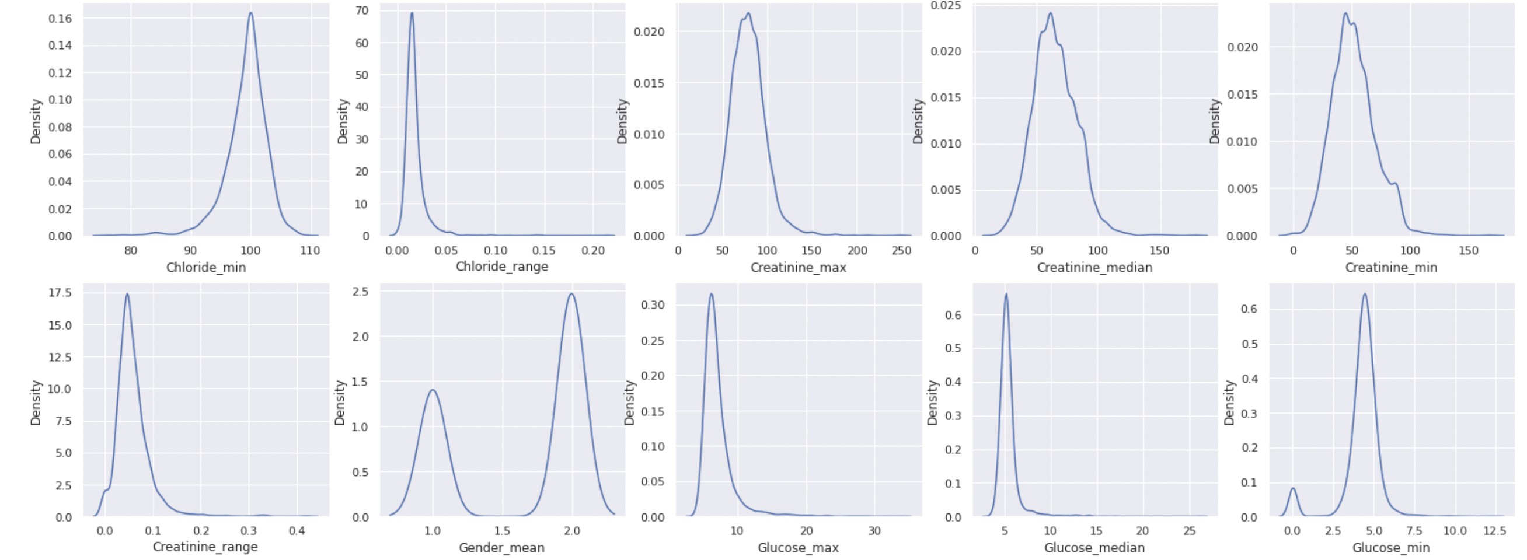

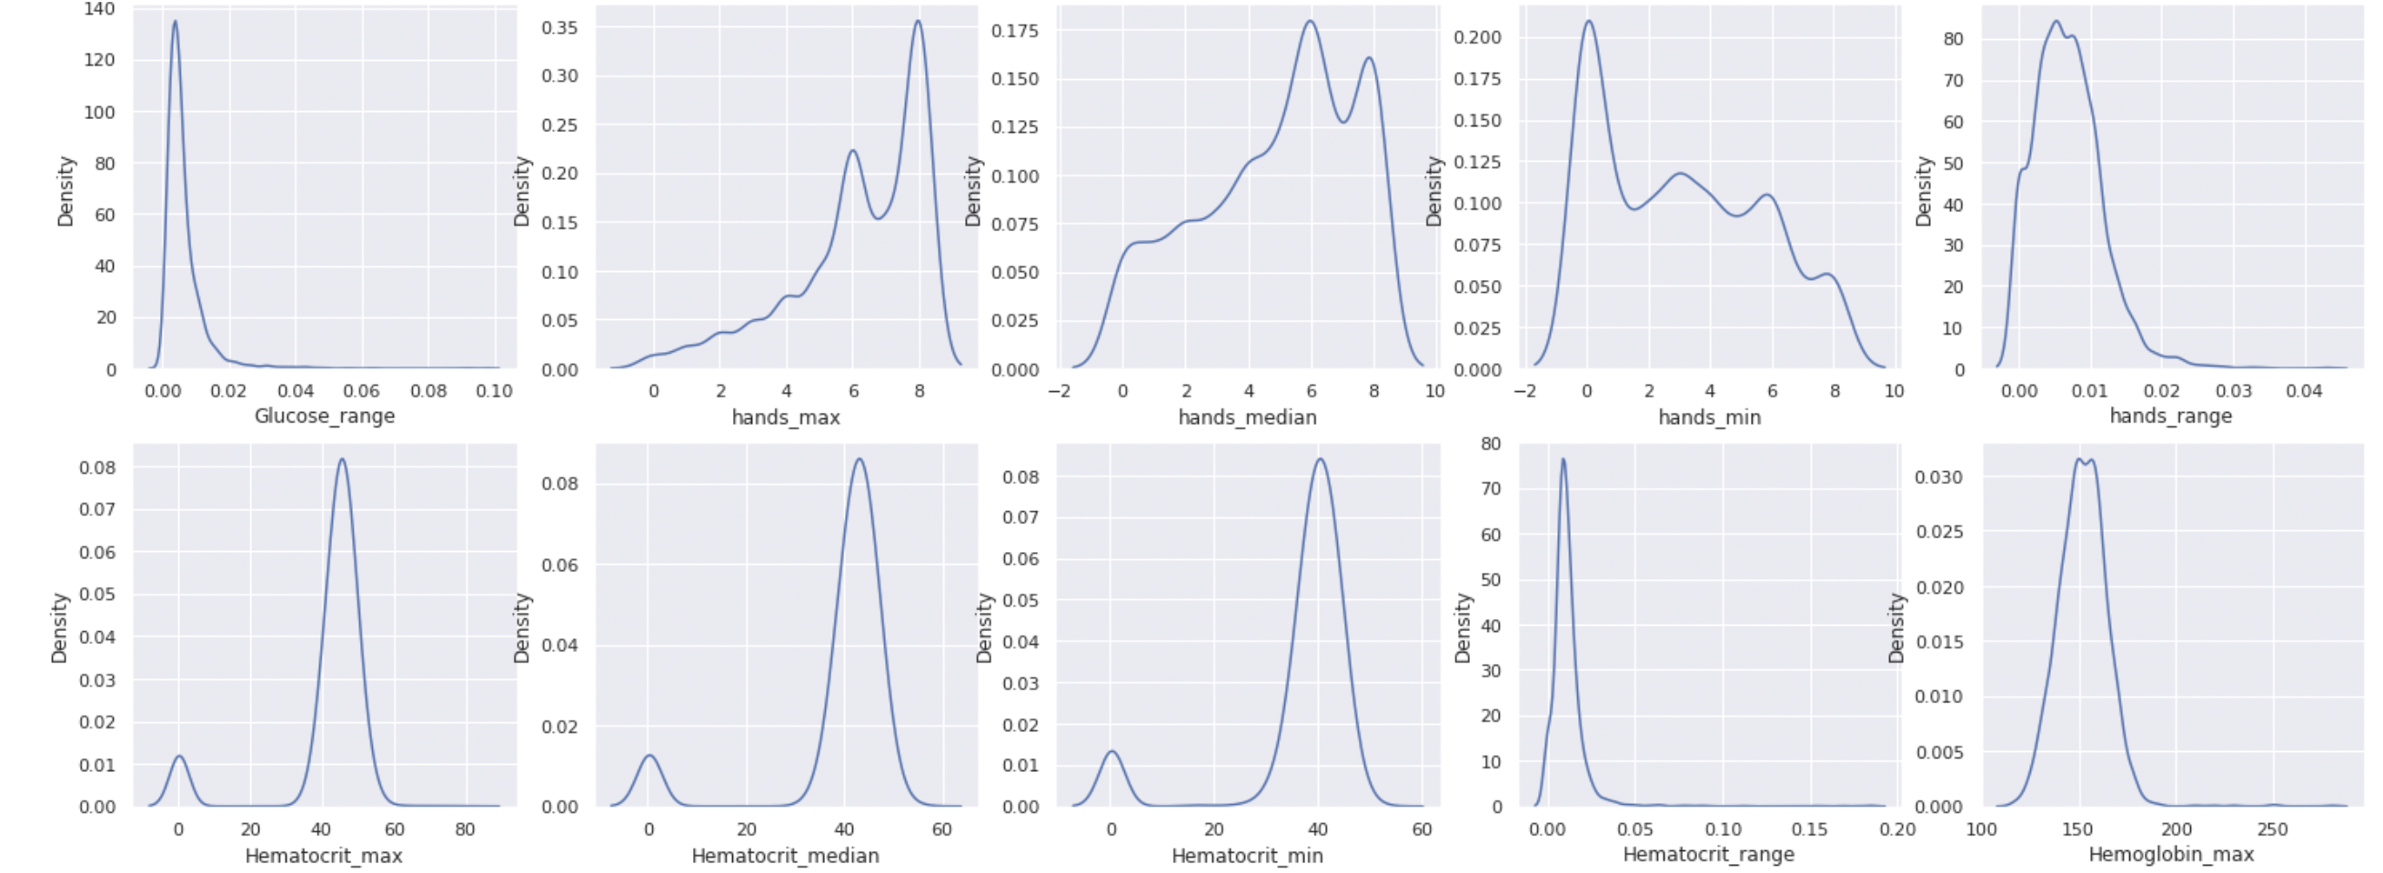

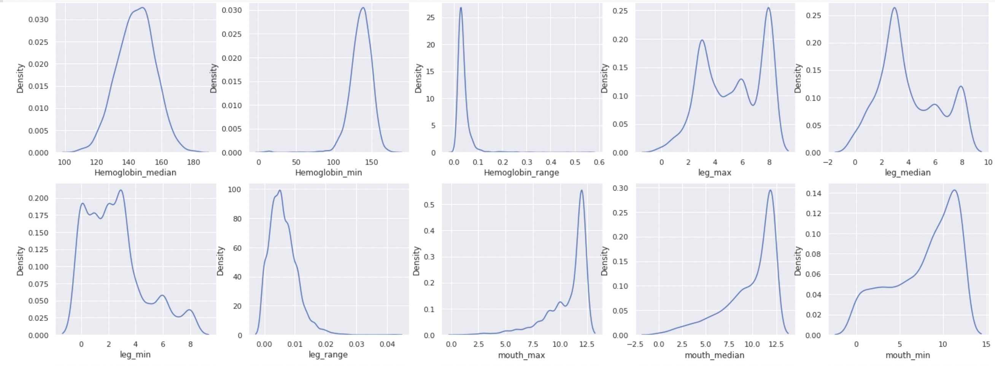

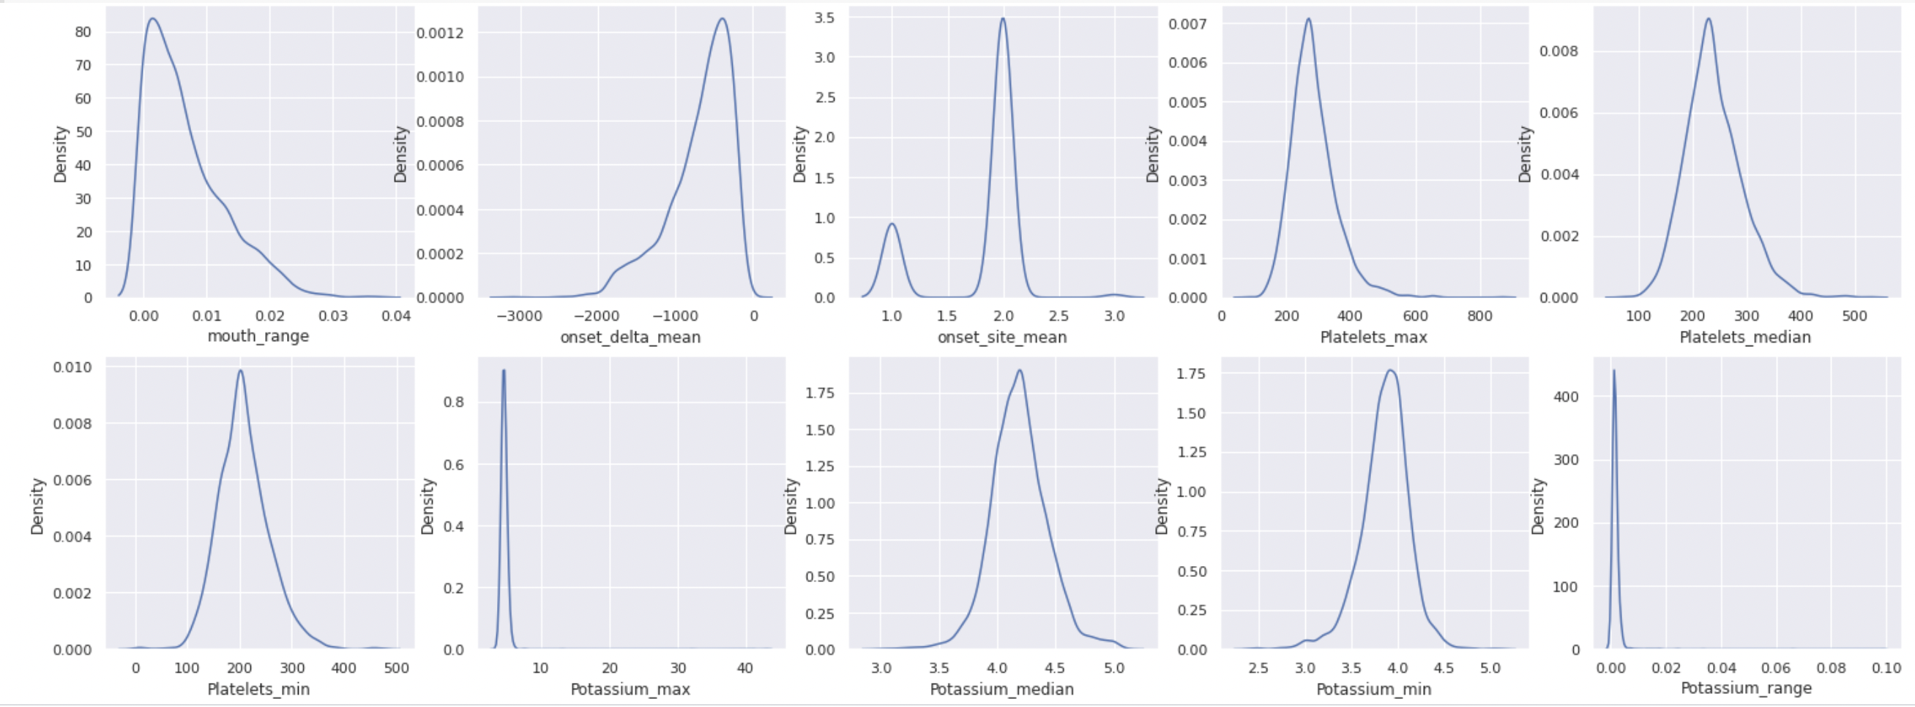

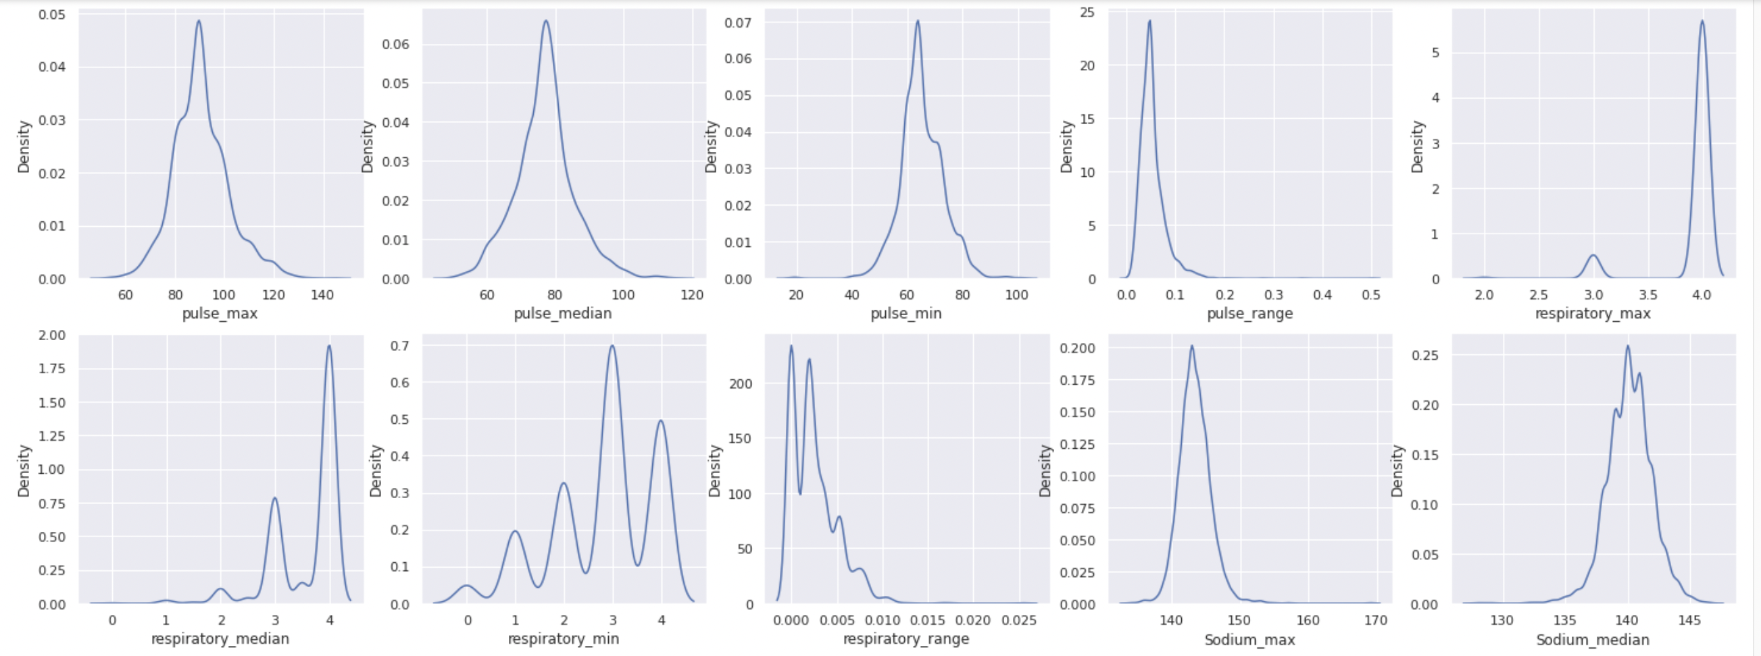

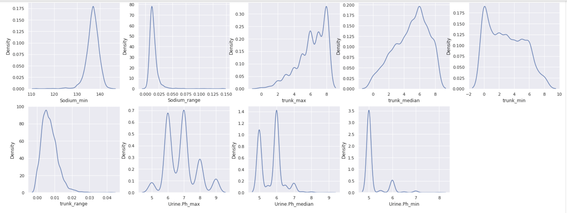

Heat Map (Co-relation):

In order to find co-relation between all the features of given data I have introduced a heat map like below.

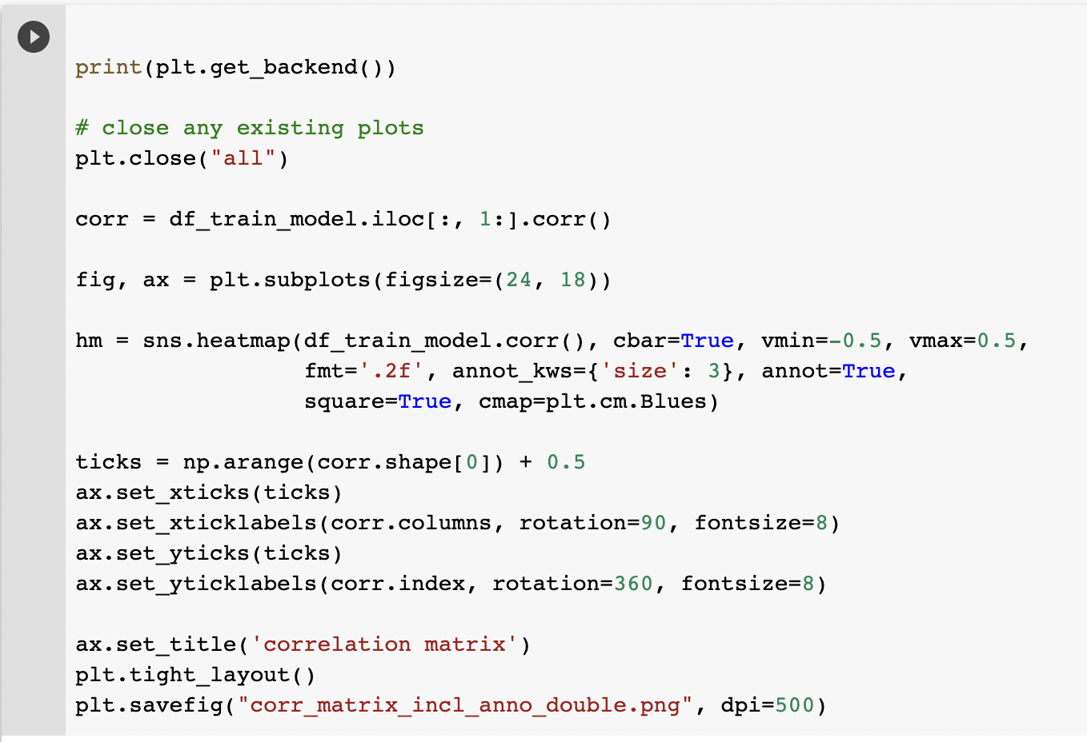

Figure of Heat Map:

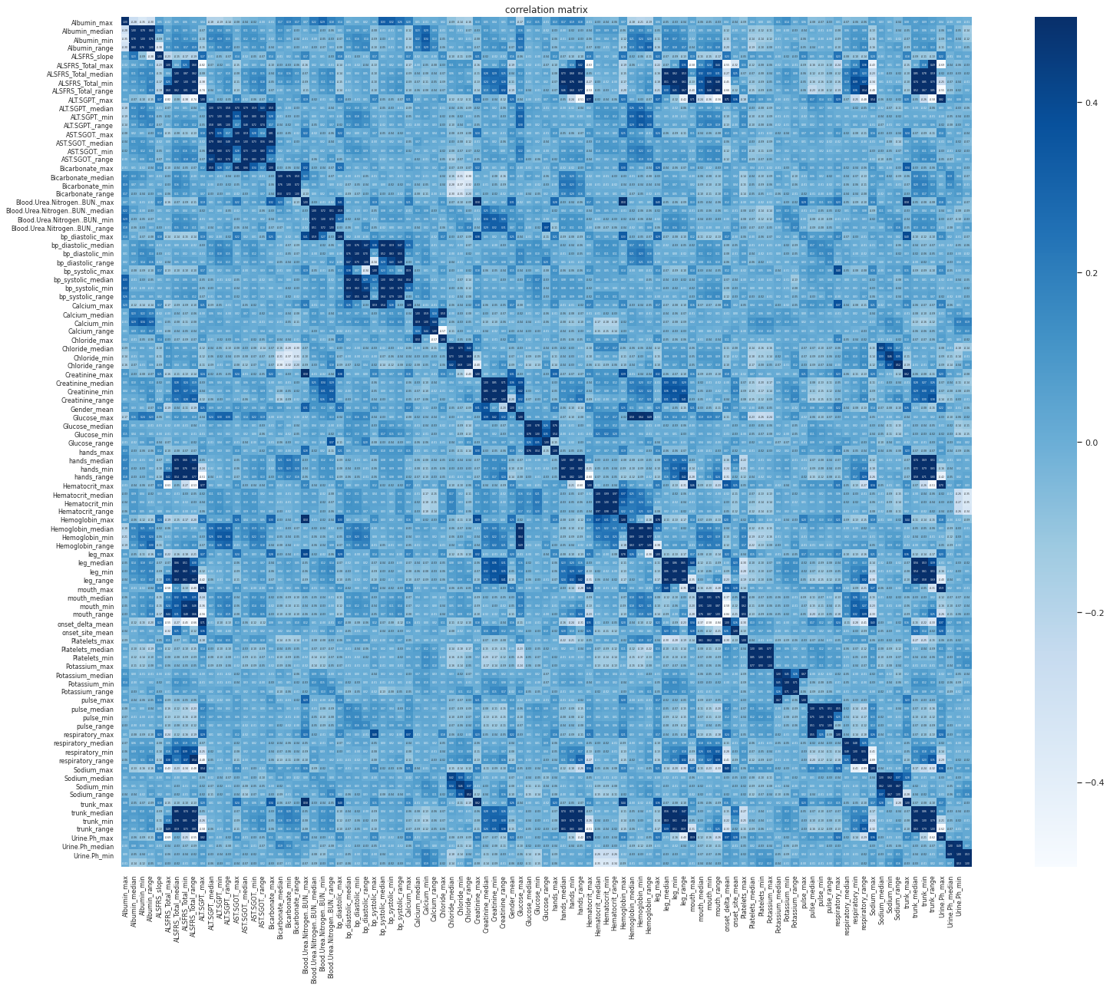

Principal Component Analysis:

As there are many features in given dataset, PCA has been introduced to reduce difficulty to understand core features out of many. After applying PCA we got significantly less and useful features of dataset, which has immensely helped to find better unsupervised clustering data model with help of K-Means algorithm.

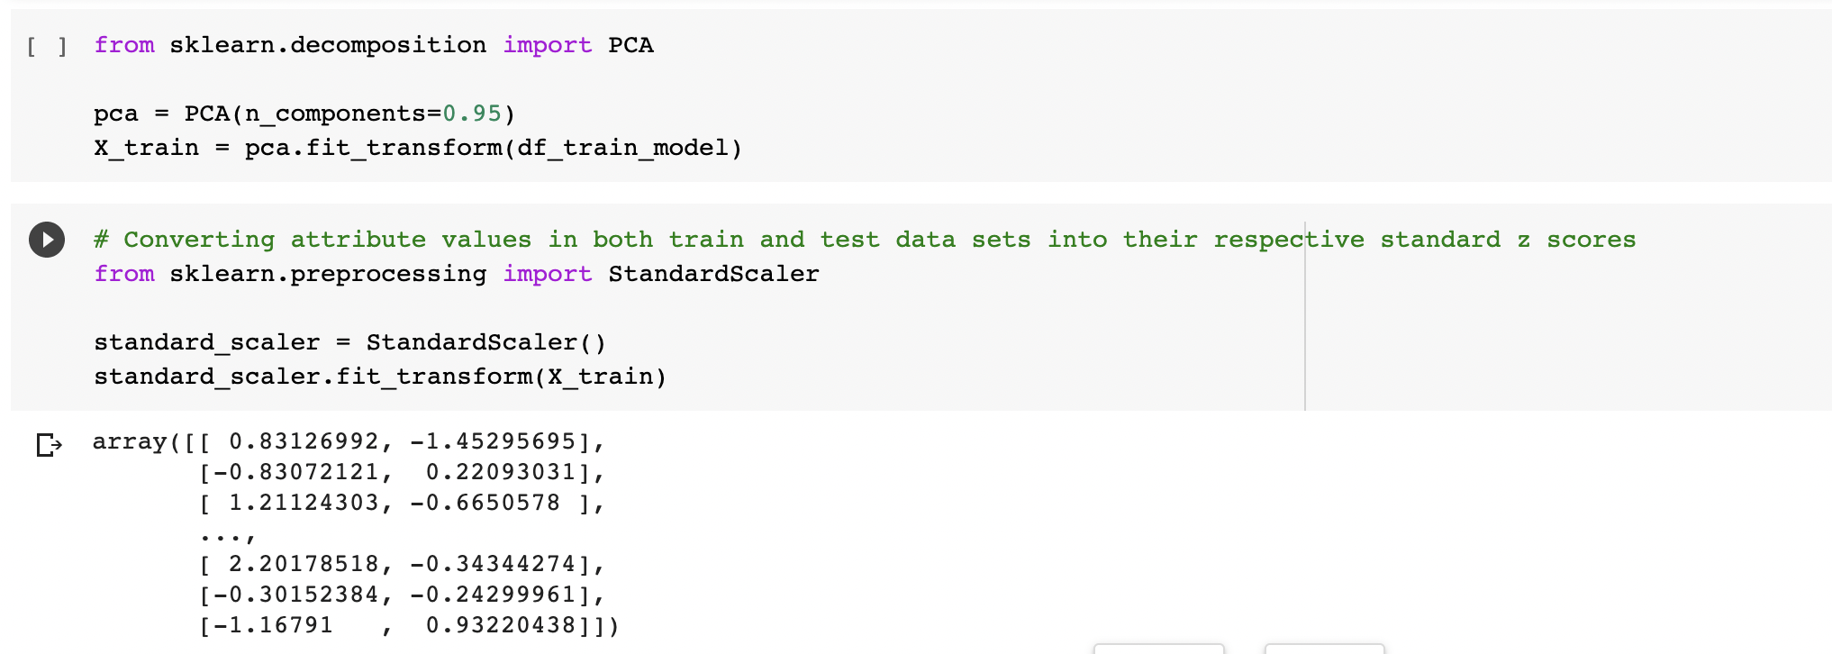

Finding optimal K value of K-Means:

To find the optimal K value of K Means, elbow method is used with inertia technique.

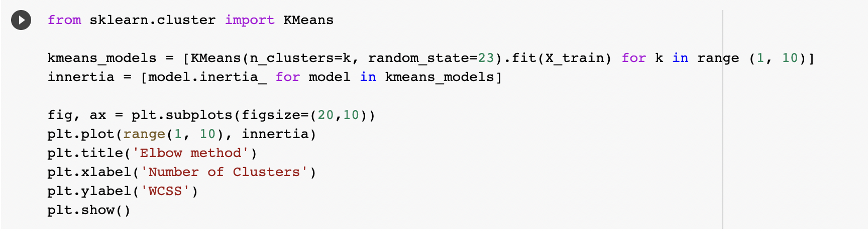

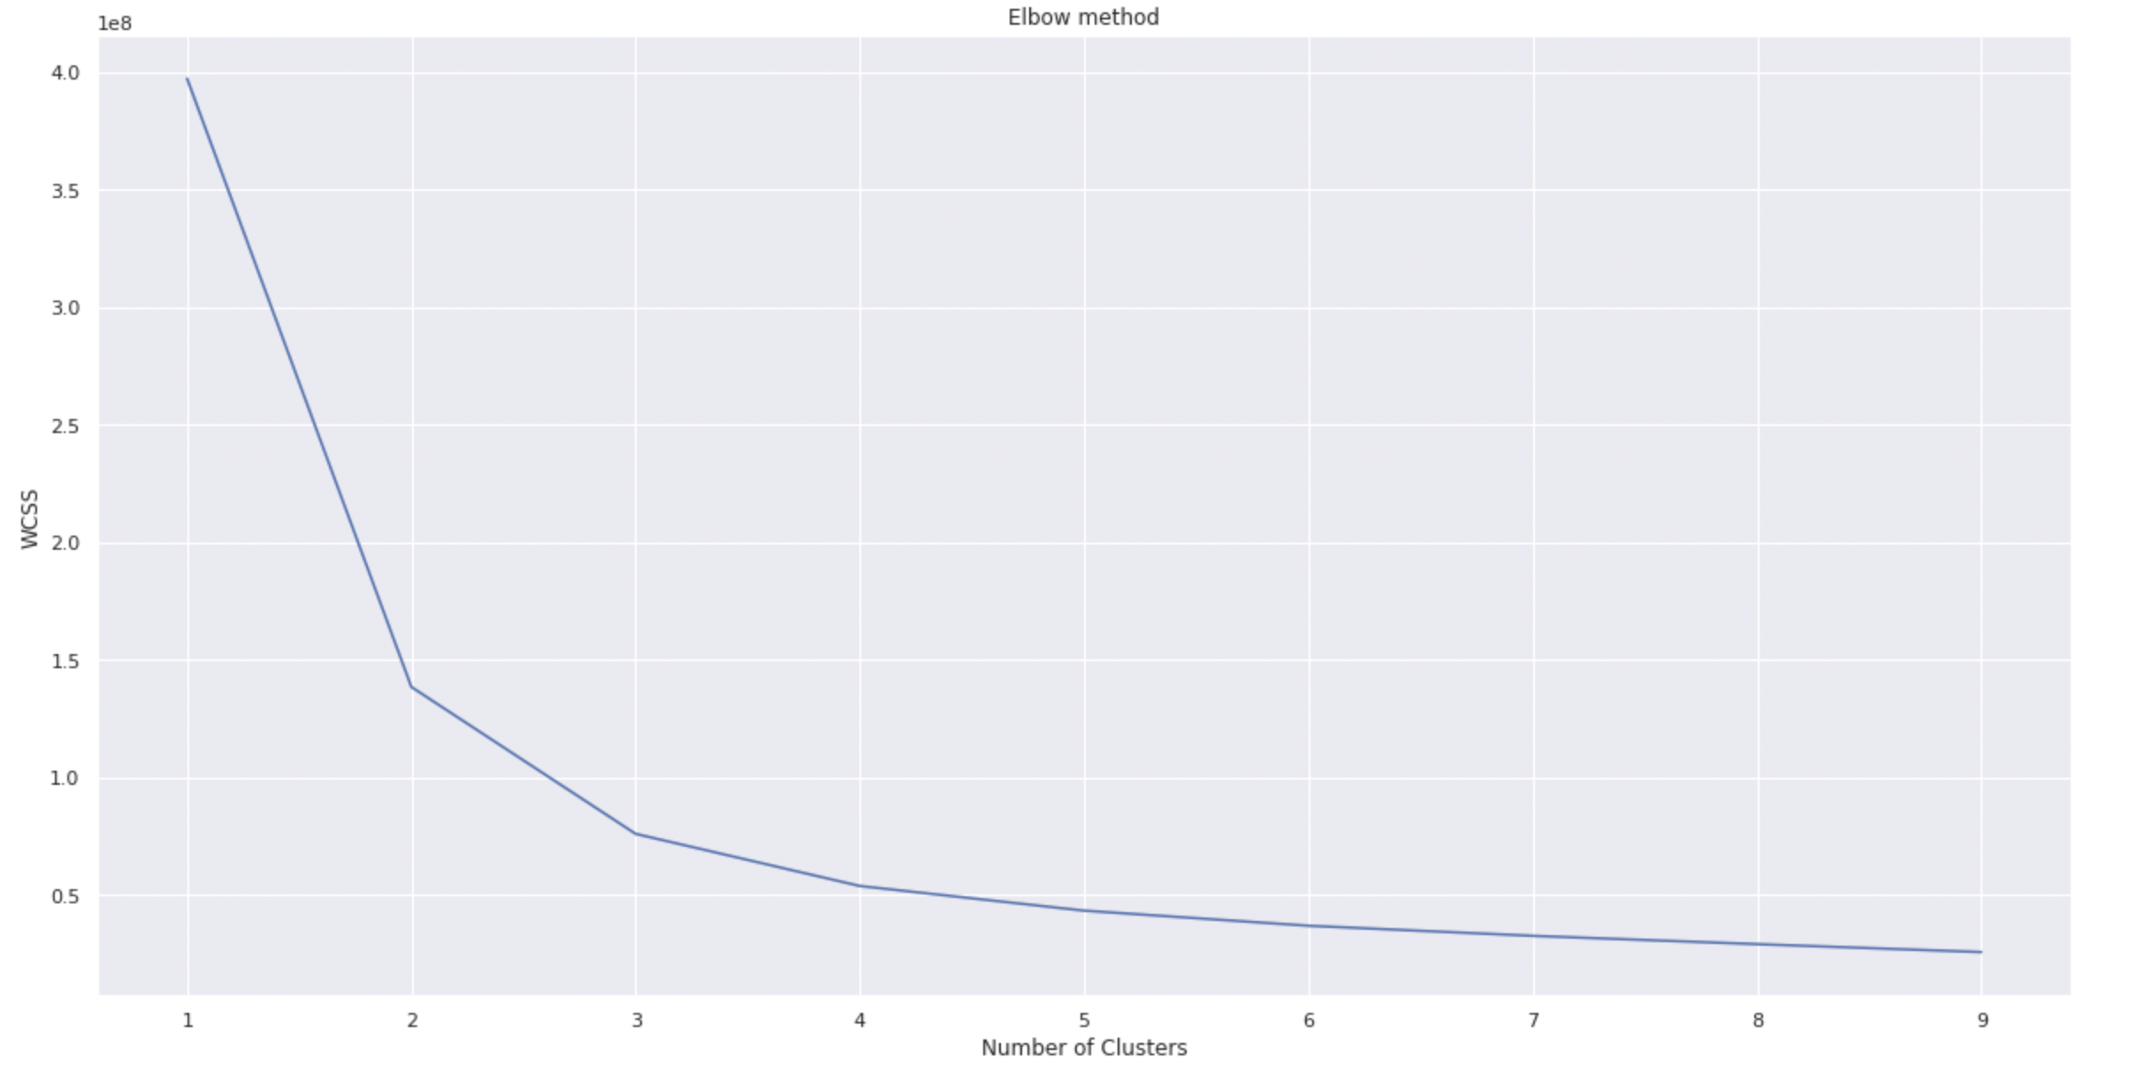

From the above graph we can say that 2, 3 and 4 are the optimal K values for the given data set.

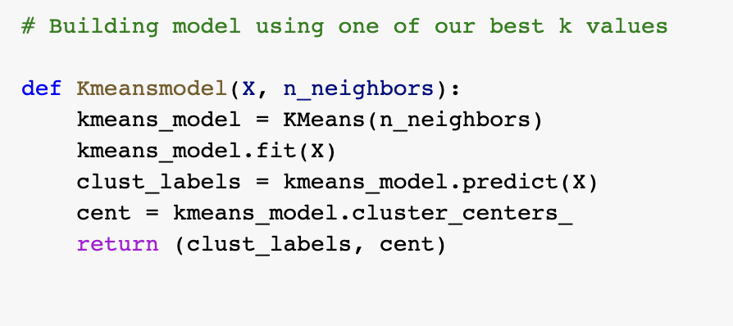

The above function is for training any given data set using K-Means which takes data set and K value as parameters.

**With the value K=2**

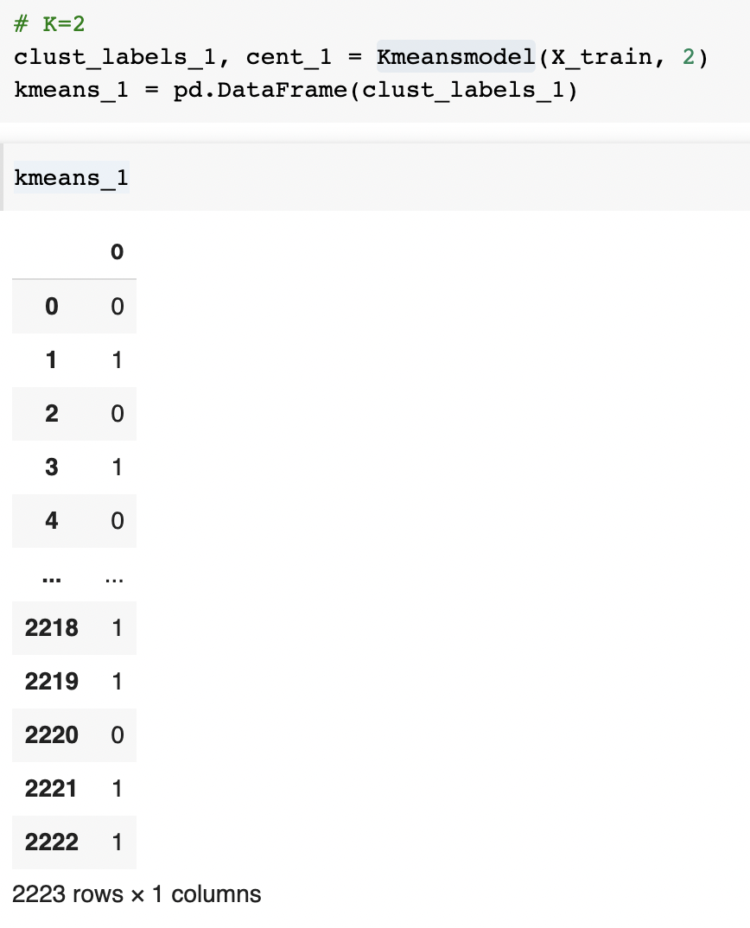

**With the value K=3**

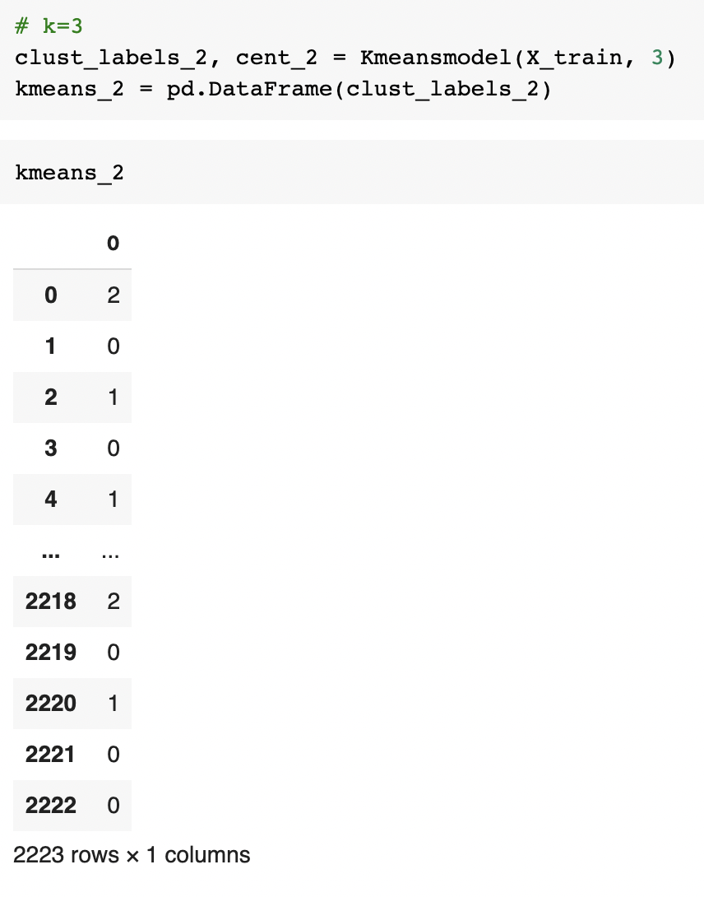

**With the value K=4**

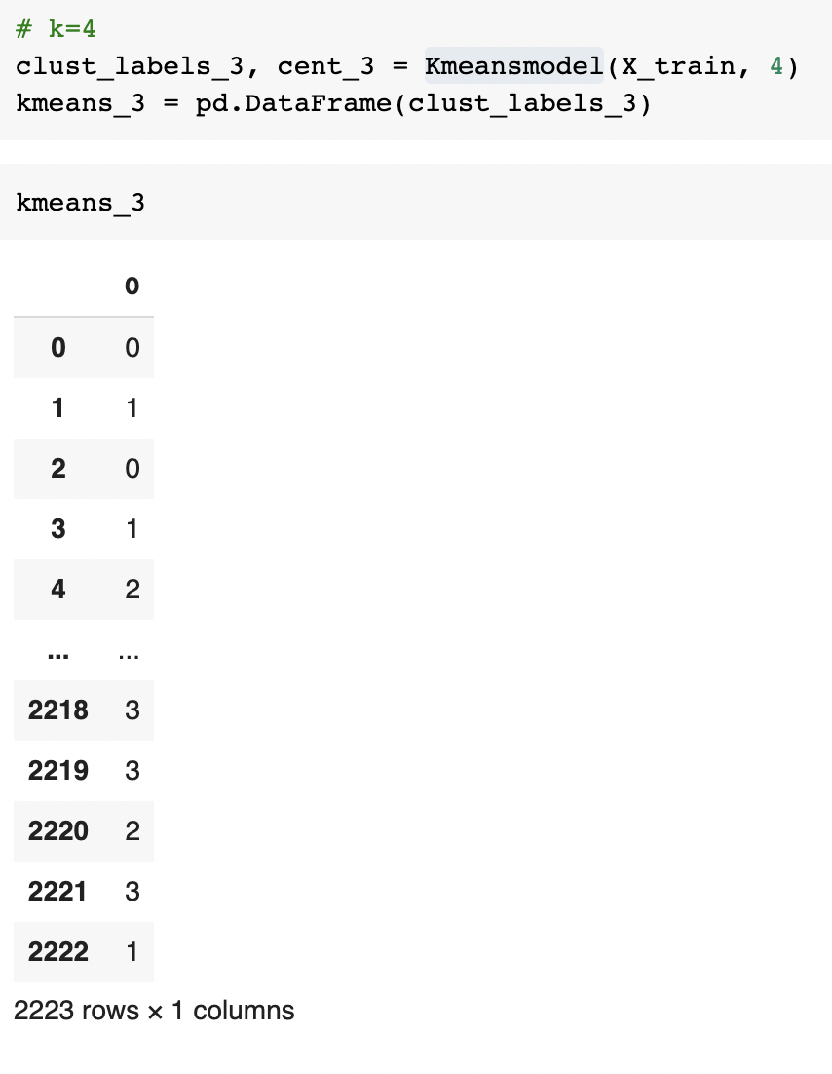

**Results of clusters developed with K =4 are visualized as follows**

The produced cluster ids are assigned as a column to the original data base.

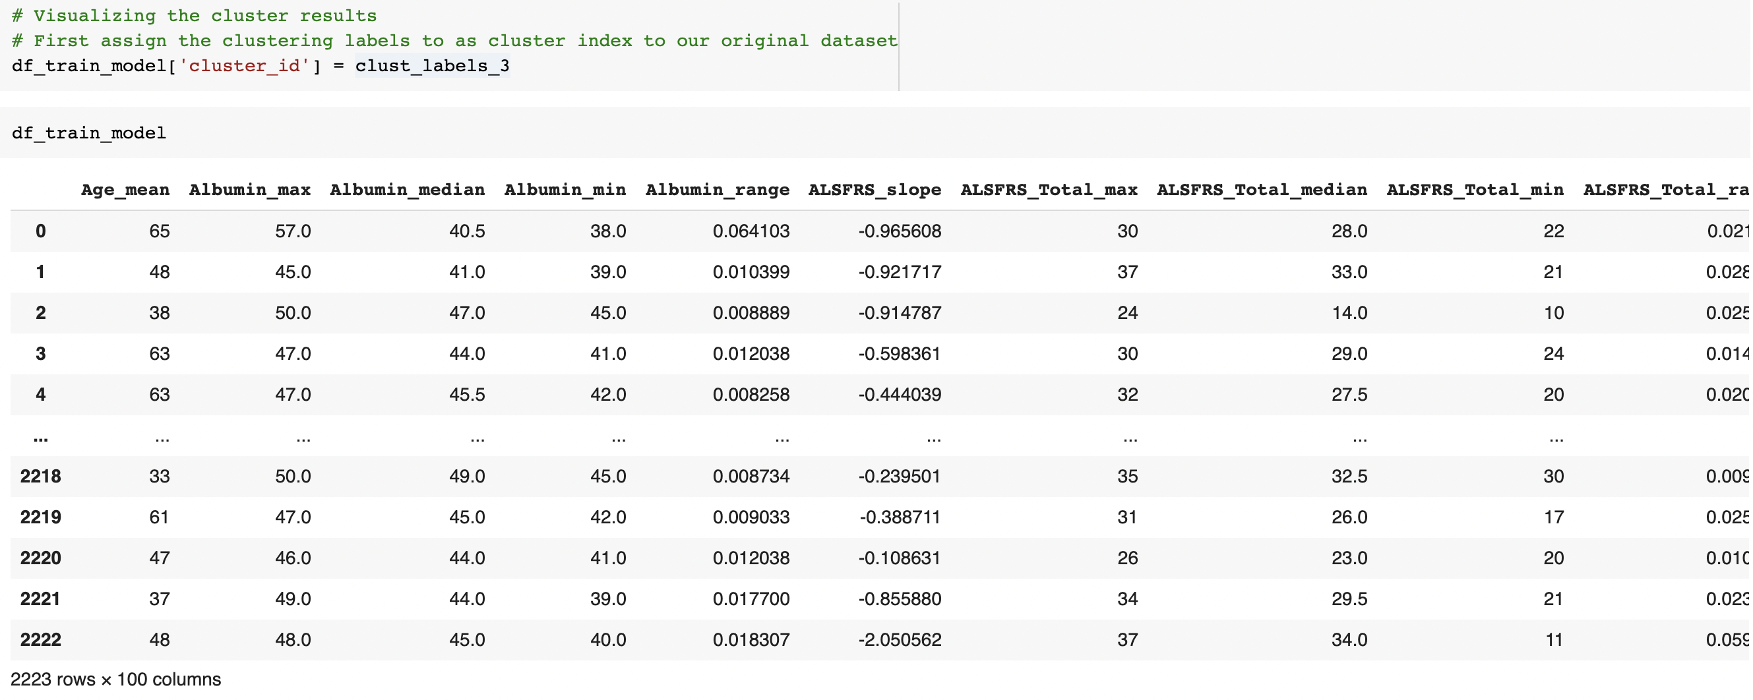

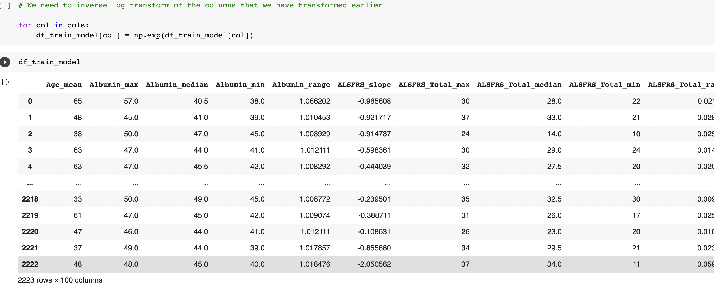

**Cluster centers with any two variables**

Clusters with Albumin_max and Albumin_median

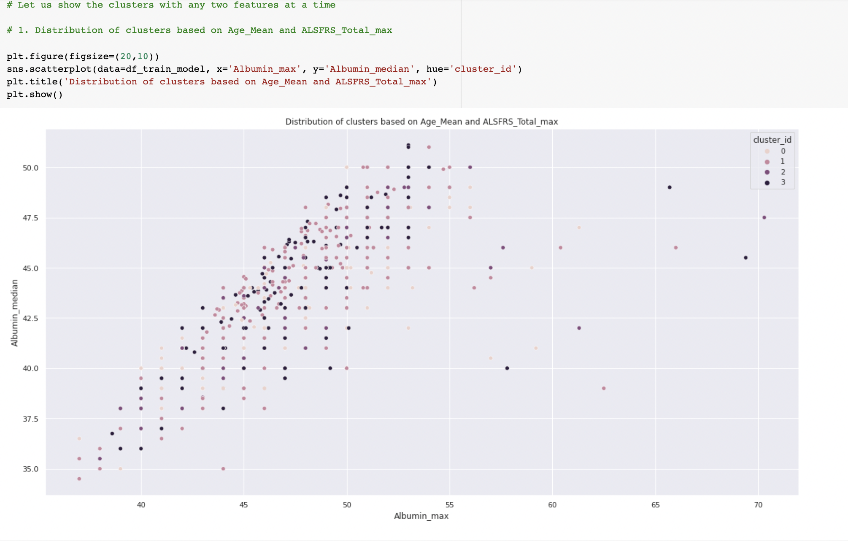

Clusters with ALSFRS_Total_max and ALSFRS_Total_min

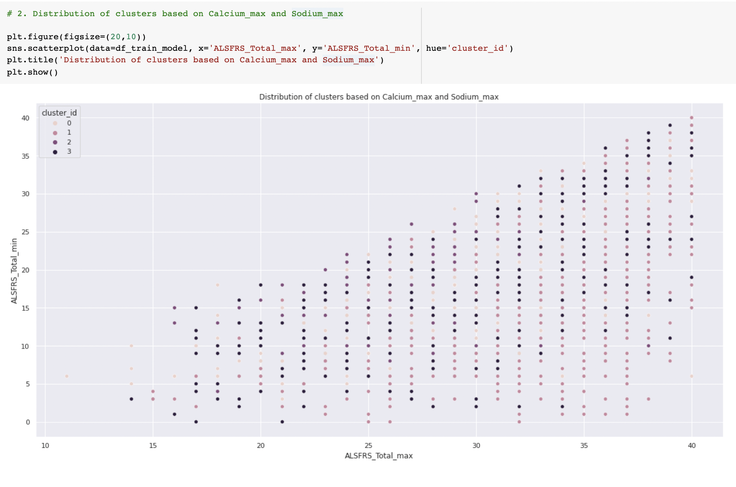

**Evaluating models:**

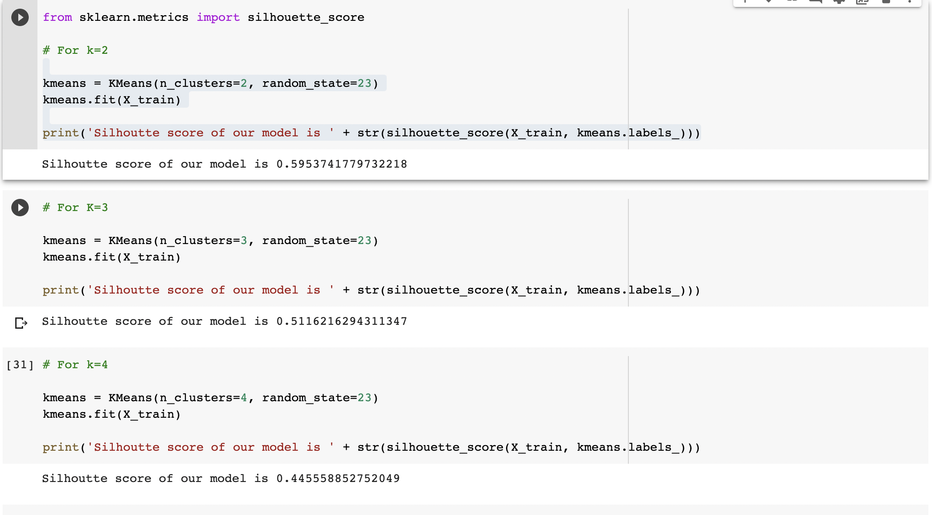

From the above screenshot we can see that silhoutte score for the model is higher when k =2. So, it can be inferred that the model developed with k value 2 is the best model.